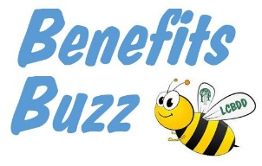
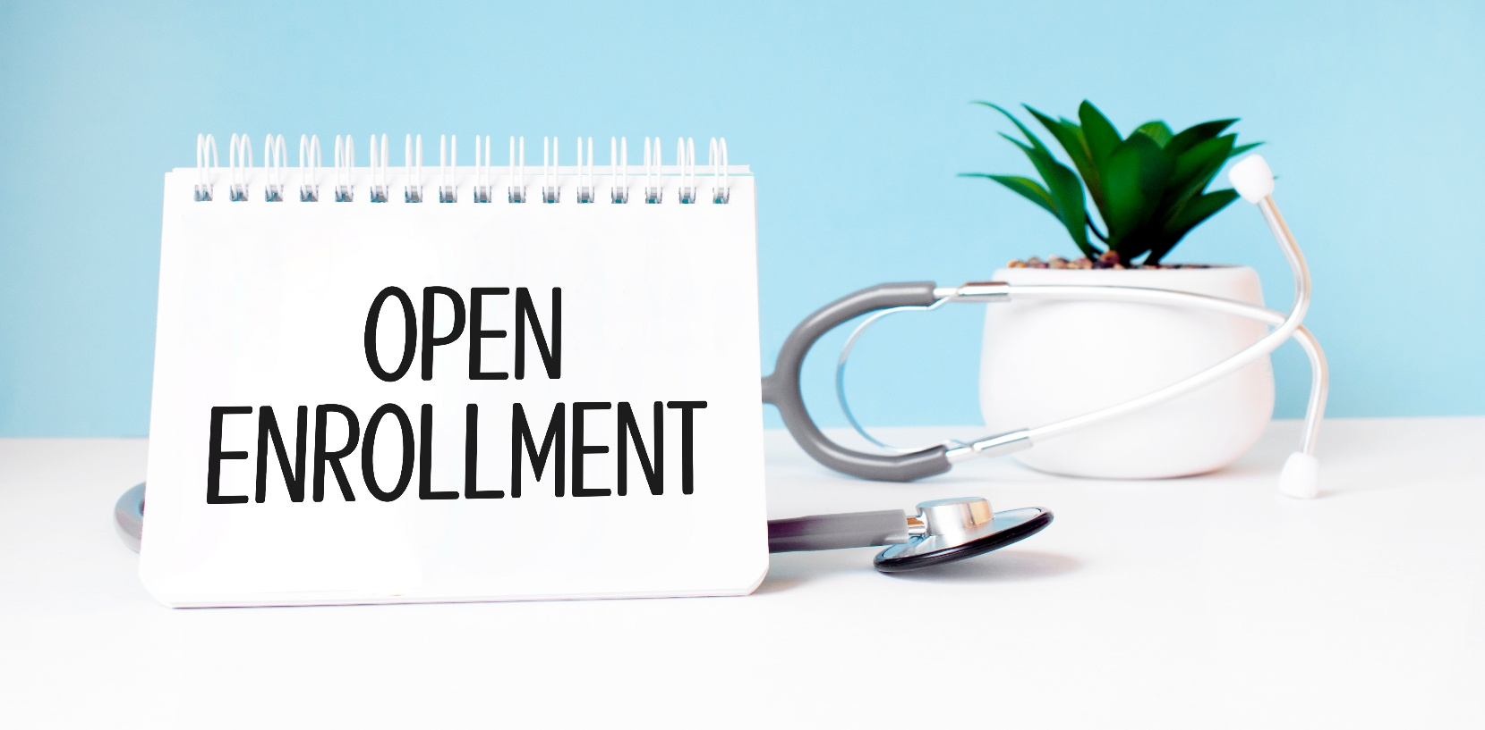
Learn what’s new and get your
benefit questions answered!

The Agency will be introducing a new Dental and Vision carrier for the 2026-2027 plan year. As a result, all employees will be required to complete new enrollment applications for Dental and Vision coverage, a new beneficiary designation form for Agency-paid Life Insurance, and applications for any elected voluntary benefits (such as Vol Life, Accident, Critical Illness, etc.)
If you are not making any changes to your medical insurance coverage, no new medical application will be required.
Additional information regarding voluntary benefit coverage will be included in your enrollment packet.

Note: Enrollment deadline is August 28, 2026, benefits are effective September 1, 2026.

Mistie Johnson, HR Generalist
Mistie.Johnson@LakeBDD.org
440-350-5062

Drop-in to one of these sessions to ask questions regarding your insurance:

- Broadmoor School
Monday, 08/24/2026
10:00 AM – 12:00 PM

- Willoughby Works
Monday, 08/24/2026
2:00 PM – 4:00 PM

- VGC
Tuesday, 08/25/2026
10:00 AM – 12:00 PM

- A-Building
Tuesday, 08/25/2026
1:00 PM – 3:00 PM

Can’t make the onsite sessions?
Call 216-487-2262 to speak with a
benefits counselor Monday - Friday
8 AM – 5 PM from August 19 – 28.
Leave a voicemail to receive a call
back within 24 hours.
.

